**RESTRICTED ACCESS**

|  |  |  |  |  |  |  |
| --- | --- | --- | --- | --- | --- | --- |
| **DISTRIBUTION :** | **Firm** | **To** | **Ref** | **Copies** | **1st page** | **e-mail** |
|  | FCE | Xavier Christmann, Claude Redon, | 8 |  |  |  |
|  | FCE | Pierre-Olivier Pilot, Sabine Flechelle, Audrey Vaché, M. Pastor, N. Bianchi, A. Dorel, Aki Saito, Sabrine Bouazizi, Wail Amri, Hmaza Zetti | 10 |  |  |  |
|  | RBE | S. Papadineti | 1 |  |  |  |
|  |  |  |  |  |  |  |
|  | FCE | Secretary ship | 1 |  |  |  |

**SW Architecture Design & Interface Description :**

**BFS sw UNIT**

OBJECT: This document is the description of the design & interfaces for *BFS* SW unit.

SUMMARY: This document provides a high-level view of the *BFS* SW unit. The inputs of this document are provided by the software requirement. It is linked to the DAIMLER_MMA_SWarchitectureDesignInterfaceDescription document.

CONCLUSION: Applicable from R01.0 SW release

**THIS DOCUMENT CONTAINS HIDDEN TEXT**

EVOLUTION OF THE DOCUMENT

|  |  |  |  |  |  |  |
| --- | --- | --- | --- | --- | --- | --- |
| **Issue** | **Date** | | **Author** | | **Motive and nature of the modifications** | |
| 1 | 31/08/2016 | | C. Redon | | First release (extract from the full PP4G architecture document) | |
| 2 | 26/09/2016 | | C. Redon | | Specification of the link between the belt function cycles and the corresponding RTE data (shared between BFS and the decision algorithms). | |
| 3 | 02/11/2016 | | C. Redon | | Coverage of TF-R | |
| Start extended description based on mainstream document | | | | | | |
| 1.1.1.2 | 10/07/2019 | | A. Vaché | | Update traceability to match PP4G extended platform requirements IDs | |
| 1.1.1.3 | 08/08/2019 | | A. Vaché | | Solve some traceability issues highlighted by reqtify | |
| Start DAIMLER MMA description based on extended document | | | | | | |
| 1.1.1.3.1 | | 06/01/22 | | 1. Negrea | | First revision |
|  | |  | |  | |  |
|  | |  | |  | |  |
|  | |  | |  | |  |
|  | |  | |  | |  |

This document contains **25** pages.

Peer Review associated to this document: *‘S:\Architectures\Application\Quality_Assurance\Peer_Review\BFS - Design Interface Description Peer Review Workbook.xls’*

**CONTENTS**

1. Documentation 5

1.1. Upper Level Relevant Documents 5

1.2. Design interface description Documents 6

1.3. Freescale Documents 8

1.4. Tier2 Documents 8

1.5. HW Datasheet 8

1.6. Other Documents 8

1.7. Glossary And Definition 9

2. Description 10

3. Technical functions 10

3.1. Selection of a belt function 11

4. Dynamic description 12

5. Runnables 13

5.1. BFS_runBeltFunctionSelection 13

5.1.1. Definition 13

5.1.2. Data flow 13

5.1.3. Called functions 21

6. MCU resources 22

**TABLE OF FIGURES**

**Figure 1: Bfs - Static description** 10

**Figure 2: Bfs - Data flow description of the belt function selection** 11

**Figure 3: Bfs - Dynamic description of the belt function selection** 12

# Documentation

## Upper Level Relevant Documents

This section presents all the documents needed to write the software architecture design document.

|  |  |  |  |
| --- | --- | --- | --- |
| Nb | **Document** | **Reference** | **Company** |
|  | TF-A: To Manage the power supply | /RevAS/30_DES_Requirements/Technical Functions/  DES_TF_A_To_Manage_The_Power_Supply | RBE/FCE |
|  | TF-B: To Manage the communication | /RevAS/30_DES_Requirements/Technical Functions/  DES_TF_B_To_Manage_The_Communication | RBE/FCE |
|  | TF-C: To Secure PP ECU functioning using Pictus MCU | /RevAS/30_DES_Requirements/Technical Functions/  DES_TF_C_To_Secure_PP_ECU_Functioning_Pictus | RBE/FCE |
|  | TF-D: To Program MCU | /RevAS/30_DES_Requirements/Technical Functions/DES_TF_D_To_Program_MCU | RBE/FCE |
|  | TF-E: To Manage Diagnostic Requests | /RevAS/30_DES_Requirements/Technical Functions/DES_TF_E_To_Manage_Diagnostic_Requests | RBE/FCE |
|  | TF-F: To Perform Measurements | /RevAS/30_DES_Requirements/Technical Functions/DES_TF_F_To_Perform_Measurements | RBE/FCE |
|  | TF-G: To Drive the Motor | /RevAS/30_DES_Requirements/Technical Functions/DES_TF_G_To_Drive_the_Motor | RBE/FCE |
|  | TF-H: To Perform Autotests | /RevAS/30_DES_Requirements/Technical Functions/DES_TF_H_To_Perform_Autotests | RBE/FCE |
|  | TF-I: To Manage the Failure | /RevAS/30_DES_Requirements/Technical Functions/DES_TF_I_To_Manage_The_Failure | RBE/FCE |
|  | TF-J: To Manage NVM - NVP (Non Volatile Parameters) | /RevAS/30_DES_Requirements/Technical Functions/DES_TF_J_To_Manage_NVM | RBE/FCE |
|  | TF-K: To Ensure ECU Protection and Integration | /RevAS/30_DES_Requirements/Technical Functions/DES_TF_K_To_Ensure_ECU_Protection_And_Integration | RBE/FCE |
|  | TF-L: To Ensure ECU Integration in Environment EMC ESD | /RevAS/30_DES_Requirements/Technical Functions/DES_TF_L_To_Ensure_ECU_Integration_In_Environment_EMC_ESD | RBE/FCE |
|  | TF-M: To generate time base | /RevAS/30_DES_Requirements/Technical Functions/DES_TF_M_To_Generate_Time_Base | RBE/FCE |
|  | TF-N: To evaluate belt data | /RevAS/30_DES_Requirements/Technical Functions/DES_TF_N_To_Evaluate_Belt_Data | RBE/FCE |
|  | TF-O: To schedule the SW | /RevAS/30_DES_Requirements/Technical Functions/DES_TF_O_To_Run_SW | RBE/FCE |
|  | TF-P: To handle network management | /RevAS/30_DES_Requirements/Technical Functions/DES_TF_P_To Handle_Network_Management | RBE/FCE |
|  | TF-Q: To Provide Data For Expertise | /RevAS/30_DES_Requirements/Technical Functions/DES_TF_Q_To_Provide_Data_For_Expertise | RBE/FCE |
|  | TF-R: To Decide Belt Function Execution | /RevAS/30_DES_Requirements/Technical Functions/DES_TF_R_To_Decide_Belt_Function_Execution | RBE/FCE |
|  | TF-S: To drive the boost | /RevAS/30_DES_Requirements/Technical Functions/DES_TF_S_To_Drive_Boost | RBE/FCE |
|  | TF-X: To generate time base | /RevAS/30_DES_Requirements/Technical Functions/DES_TF_M_To_Generate_Time_Base | RBE/FCE |

## Design interface description Documents

This section presents all the documents that are linked to this software architecture design document.

Note: All links are related to S:\drive, to have them functional, please mount the S:\drive on your Audi Tr6 extended platform sandbox.

|  |  |  |  |
| --- | --- | --- | --- |
| Nb | **Document** | **Reference** | **Company** |
|  | EEPROM parameters | SBE_4G_NVP_layout.xls | RBE/FCE |
|  | Design Interface description of AdcIf | N/A | RBE/FCE |
|  | Design Interface Description of Auto Tests Manager | N/A | RBE/FCE |
|  | Design Interface Description of Belt Function Decision | N/A | RBE/FCE |
|  | Design Interface Description of Belt Function Execution | BFE - Design Interface Description.docx | RBE/FCE |
|  | Design Interface Description of Belt Function Selection | BFS - Design Interface Description.docx | RBE/FCE |
|  | Design Interface Description of Belt Movement Monitoring | N/A | RBE/FCE |
|  | Design Interface Description of Belt Parking Algorithm | N/A | RBE/FCE |
|  | Design Interface Description of Belt Slack Reduction | N/A | RBE/FCE |
|  | Design Interface Description of Basic Software Manager | N/A | RBE/FCE |
|  | Design Interface Description of Basic Software Manager Interface | N/A | RBE/FCE |
|  | Design Interface Description of Can Tranceiver Interface | N/A | RBE/FCE |
|  | Design Interface Description of Communication Interaction Layer | CIL - Design Interface Description.docx | RBE/FCE |
|  | Design Interface Description of Diagnostic Communication Manager Interface | N/A | RBE/FCE |
|  | Design Interface Description of Diagnostic Event Manager Interface | N/A | RBE/FCE |
|  | Design Interface Description of DiagOnCAN services management | DIA - Design Interface Description.docx | RBE/FCE |
|  | Design Interface Description of Electronic Control Unit Manager | N/A | RBE/FCE |
|  | Design Interface Description of Electronic Control Unit Manager Interface | N/A | RBE/FCE |
|  | Design Interface Description of End of life | N/A | RBE/FCE |
|  | Design Interface Description of Error Handler | N/A | RBE/FCE |
|  | Design Interface Description of Haptic Warning | N/A | RBE/FCE |
|  | Design Interface Description of Memory Integrity Control | N/A | RBE/FCE |
|  | Design Interface Description of Mode Management | MMG - Design Interface Description.docx | RBE/FCE |
|  | Design Interface Description of Network Management Interface | N/A | RBE/FCE |
|  | Design Interface Description of Non-Volatile Memory Interface | N/A | RBE/FCE |
|  | Design Interface Description of Non-Volatile Parameters | NVP - Design Interface Description.docx | RBE/FCE |
|  | Design Interface Description of Operating System Interface | N/A | RBE/FCE |
|  | Design Interface Description of Power Abstraction Layer | PAL - Design Interface Description.docx | RBE/FCE |
|  | Design Interface Description of Pre-Crash Master | N/A | RBE/FCE |
|  | Design Interface Description of Physical Measures Provider | PMP - Design Interface Description.docx | RBE/FCE |
|  | Design Interface Description of Port Interface | N/A | RBE/FCE |
|  | Design Interface Description of Pre Pre-Tensioning | PRE - Design Interface Description.docx | RBE/FCE |
|  | Design Interface Description of Production cycle function | N/A | RBE/FCE |
|  | Design Interface Description of Pulse Width Modulation Interface | N/A | RBE/FCE |
|  | Design Interface Description of Reset Cause Management | N/A | RBE/FCE |
|  | Design Interface Description of SBC | N/A | RBE/FCE |
|  | Design Interface Description of System Context Management | N/A | RBE/FCE |
|  | Design Interface Description of Standard Function Recovery (releasing function) | SFR - Design Interface Description.docx | RBE/FCE |
|  | Design Interface Description of Serial Peripheral Interface Interface | N/A | RBE/FCE |
|  | Design Interface Description of Startup | N/A | RBE/FCE |
|  | Design Interface Description of System Time Management | N/A | RBE/FCE |
|  | Design Interface Description of Vehicle Dynamics algorithm | N/A | RBE/FCE |

## Freescale Documents

This section presents all the documents that complete this software architecture design document.

|  |  |  |  |
| --- | --- | --- | --- |
| Nb | **Document** | **Reference** | **Company** |
|  | MC9S12ZVC-Family Reference Manual Preliminary  Confidential | MC9S12ZVCRM_Rev0.06.pdf | Freescale |
|  |  |  |  |
|  |  |  |  |
|  |  |  |  |

## Tier2 Documents

This section presents all the documents that complete this software architecture design document.

|  |  |  |  |
| --- | --- | --- | --- |
| Nb | **Document** | **Reference** | **Company** |
|  |  |  |  |
|  |  |  |  |
|  |  |  |  |
|  |  |  |  |

## HW Datasheet

This section presents all the documents related to the HW components that complete this software architecture design document.

|  |  |  |  |
| --- | --- | --- | --- |
| Nb | **Document** | **Reference** | **Company** |
|  | BTN8984TA datasheet | BTN8984TA_TDS_051 | Infineon |
|  |  |  |  |
|  |  |  |  |
|  |  |  |  |

## Other Documents

This section presents all the documents that also have been needed to write this software architecture design document.

|  |  |  |  |
| --- | --- | --- | --- |
| Nb | **Document** | **Reference** | **Company** |
|  | Unified Modelling Language | 2.1.1 | OMG |
|  | MCU RFQ | [E2581849](https://plm.autoliv.int/linkto/latest/ProductDescription/E2581849/*) | FCE |
|  |  |  |  |

## Glossary And Definition

This section presents all the definitions and/or abbreviations used in this document.

*List of terms in alphabetical order:*

|  |  |
| --- | --- |
| ***Term*** | ***Meaning*** |
| ADC | Analog Digital Converter |
| AEC | Autoliv Error Code |
| API | Application Programming Interface |
| ASDM | Active Safety Domain Master |
| ASIC | Application Specific Integrated Circuit |
| ASY | Active SafetY |
| BSW | Basic SW modules |
| CAN | Controller Area Network |
| C/S | Chip Select |
| COP | Computer Operating Properly |
| eCPL | Electronic Crash Pole Locking |
| DART | Ditch - Airborne - Rough Terrain |
| DFLASH | Data FLASH |
| ECC | Error Code Correction |
| ECU | Electronic Control Unit |
| EOL | End Of Life |
| EEPROM | Electric Erasable and Programmable Read only Memory |
| HFPP | High Force Pre-Pre-Tensioning belt function |
| HF-PRE | High Force PRE pre-tensioning |
| HR | Hard Releasing |
| I/O | Input/Output |
| IMU | Inartial Measurements Unit |
| ISS | Integrated Safing System |
| LFPP | Low Force Pre-Pre-Tensioning belt function |
| MSA | Motor Start/Stop Automatic |
| MCAL | Micro-Controller Abstraction Layer |
| MCU | Micro-controller Unit |
| NMG | Mode ManaGement |
| NVM | Non Volatile Memory |
| OS | Operating System |
| PCM | Pre-Crash Master |
| PFLASH | Program FLASH |
| PIT | Periodic Interrupt Timer |
| PLL | Phase-locked loop |
| RAM | Random Access Memory |
| RCWM | Rear Collision Warning and Mitigation |
| RML | Left PP ECU |
| RMR | Right PP ECU |
| RMx | Both PP ECU |
| ROM | Read Only Memory |
| RSU | Remote Sensor Unit |
| RTE | Real Time Environment |
| RTOS | Real Time Operating System |
| SFR | Standard Function Recovery |
| SODL | Side Obstacle Detection Left |
| SPI | Serial Peripheral Interface |
| SRS | Supplementary Restraint System |
| TBC | To be confirmed |
| TBD | To be defined |
| TF | Technical Function |
| TFLASH | Test FLASH of the Pictus MCU (“one time programmable” memory) |
| W/D | Watchdog |

# Description

The BFS component is intended to select the belt function to execute based on:

* The output of each decision matrix / algorithm (PRE, SFR)
* The current executed belt function
* The priority of each belt function

# Technical functions

|  |  |  |  |
| --- | --- | --- | --- |
| **Requirements** | **Criteria** | **Levels/Tolerances** | **Source** |
| ARCH_SW_BFS_0000 | This component shall implement the TF-R4 technical function. Refer to *[A15]* for more details. |  |  |



The figure below shows the static description of the module.

As depicted by this figure, the interaction of the BFS component with the application is quite simple. To sum-up, BFS is connected with:

1. The output of all the belt functions decision algorithms (trigger & interrupt orders)
2. The BFE to get the current executed belt function
3. The NVP to load the priority rules between the belt functions (pre-crash, releasing and production)

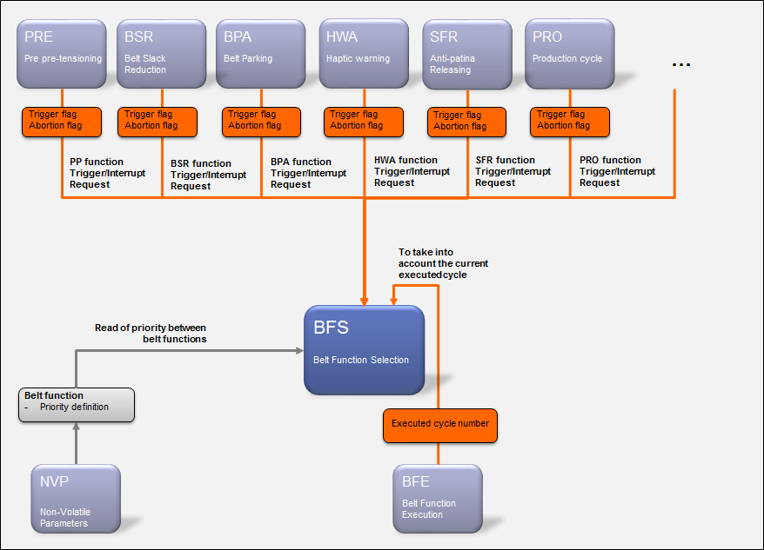Based on these information, BFS will then select the belt function having the highest priority to execute.

**Figure 1: Bfs - Static description**

## Selection of a belt function

As depicted by the figure below, the selection of the belt function consists in:

* Reading all trigger and interrupt flags from the belt function decision algorithms
  + X2 Pre pre-tensioning decision algorithm
  + X1 Standard function recovery decision algorithm
* Reading the current executed belt function
* Considering the priority table of the belt functions

Based on that, BFS will provide the “selected belt function” to BFE.

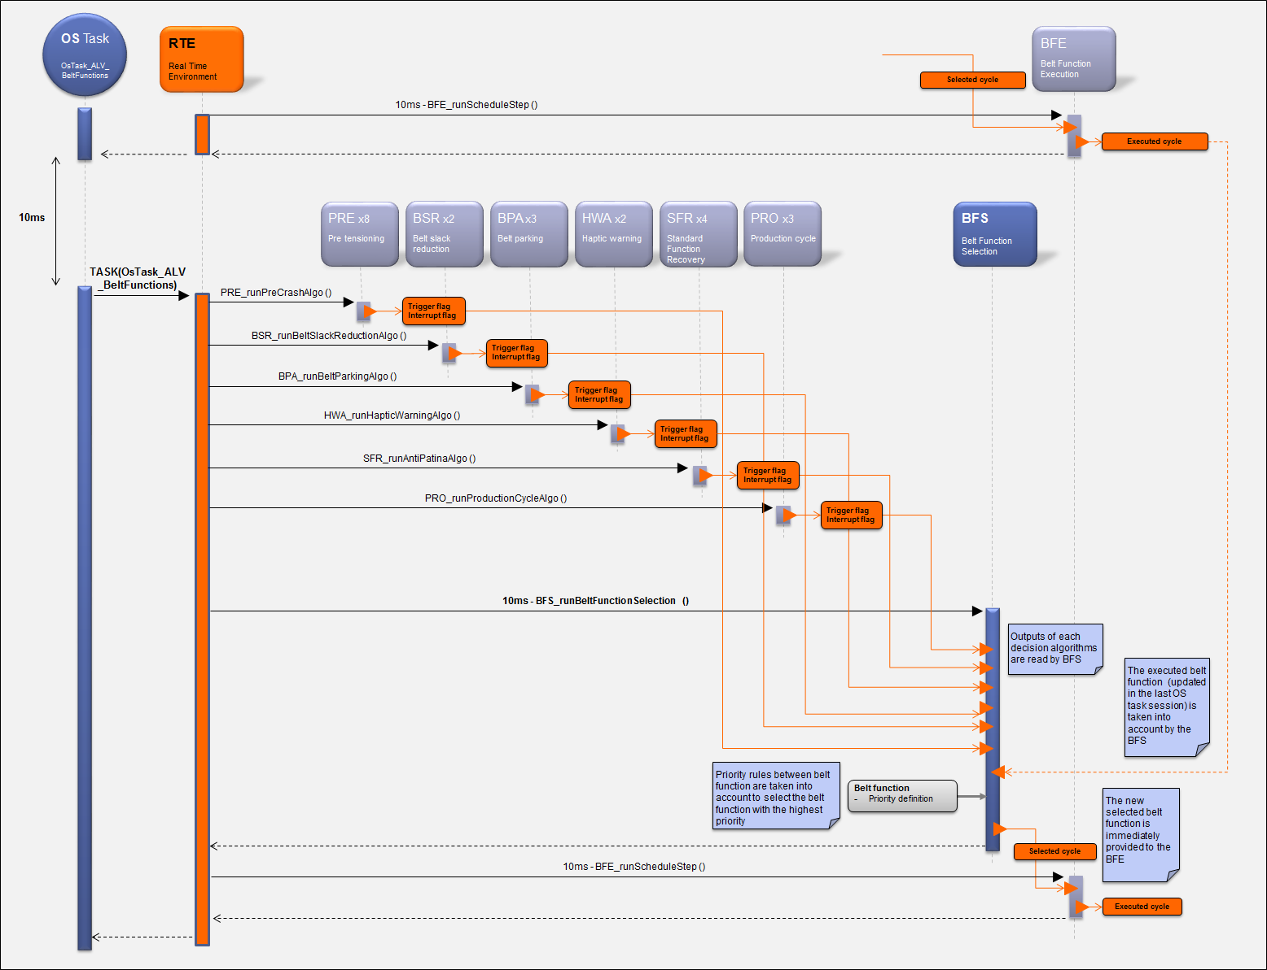

**Figure 2: Bfs - Data flow description of the belt function selection**

# Dynamic description

As depicted by the figure below, the dynamic description related to the BFS component is very simple. Only one function will be periodically called by the scheduler.

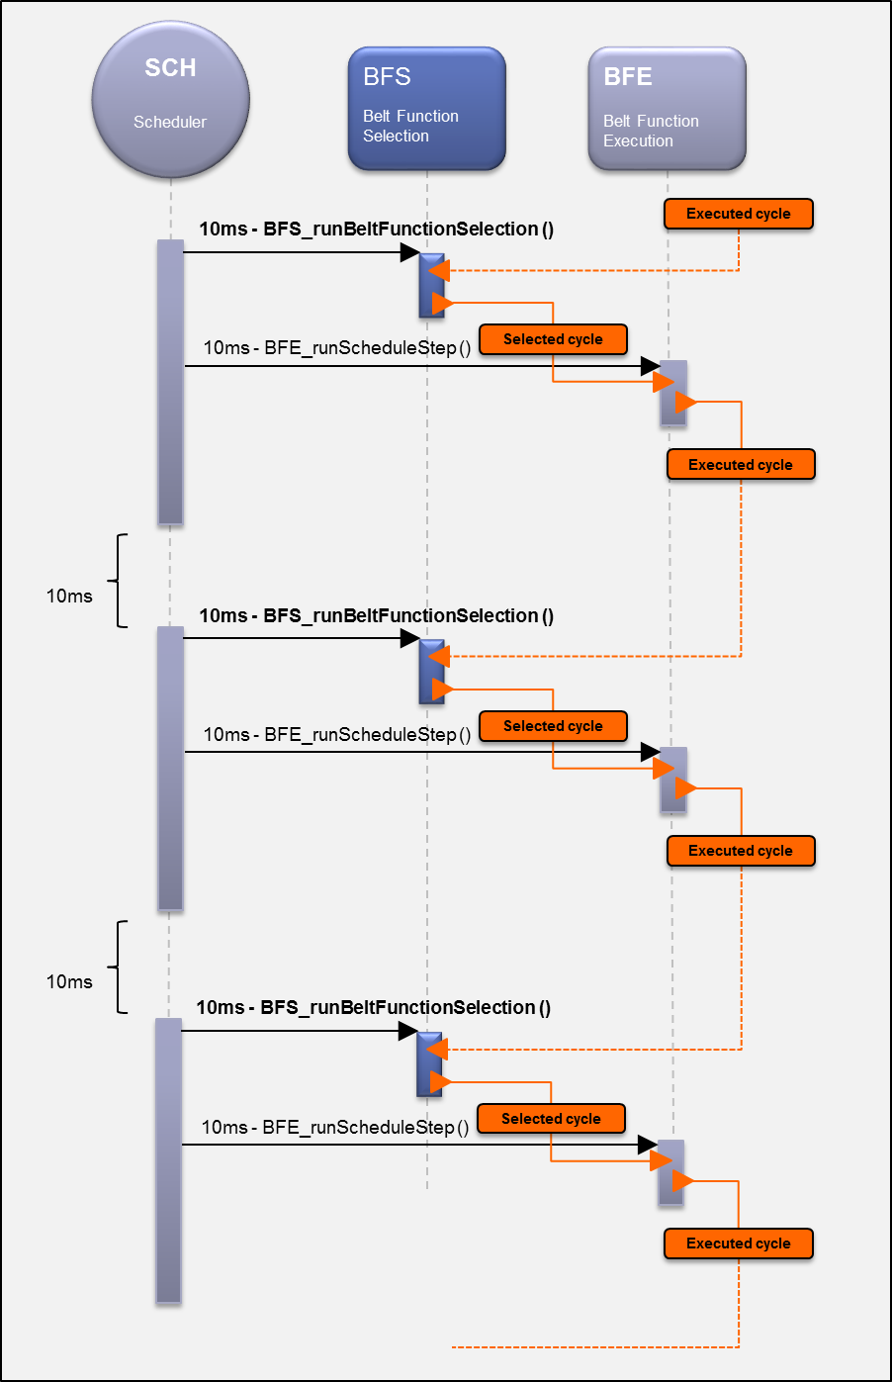

**Figure 3: Bfs - Dynamic description of the belt function selection**

# Runnables

## BFS_runBeltFunctionSelection

### Definition

|  |  |  |  |
| --- | --- | --- | --- |
| **Prototype** | | | |
| void BFS_runBeltFunctionSelection (void) | | | |
| **Object** | | | |
| The BFS component shall provide the BFS_runBeltFunctionSelection function.  This function will select the belt function to execute in function to:   * The output of the decision algorithms * The priority of the belt functions | | | |
| **Parameters** | | | |
| Name | Type | Direction | Description |
| NA | NA | NA | NA |
| **Returned value** | | | |
| Name | Description | | |
| NA | NA | | |
| **Dynamic aspect** | | | |
| Periodic – 10ms  Non reentrant | | | |
| **Requirements** | | | |
| ARCH_SW_BFS_0010 | | | |
| **Covered requirements** | | | |
|  | | | |

### Data flow

#### Pre pre-tensioning decision flags

|  |  |  |  |
| --- | --- | --- | --- |
| **Requirements** | **Criteria** | **Justifications/Levels/Tolerances** | **Source** |
| **ARCH_SW_BFS_0021** | **PRE** **trigger flag #1** shall be read by the BFS_runBeltFunctionSelection function.  This flag is linked to the pre pre-tensioning cycle level #0. | Data access mode: Explicit  Justification:  All SW units related the belt functions are mapped into the same execution task context.  Therefore, a direct access to the very last update of the date is mandatory. |  |
| **ARCH_SW_BFS_0022** | **PRE** **trigger flag #2** shall be read by the BFS_runBeltFunctionSelection function.  This flag is linked to the pre pre-tensioning cycle level #1. | Data access mode: Explicit  Justification:  All SW units related the belt functions are mapped into the same execution task context.  Therefore, a direct access to the very last update of the date is mandatory. |  |
| **ARCH_SW_BFS_0023** | **PRE** **trigger flag #3** shall be read by the BFS_runBeltFunctionSelection function.  This flag is linked to the pre pre-tensioning cycle level #2. | Data access mode: Explicit  Justification:  All SW units related the belt functions are mapped into the same execution task context.  Therefore, a direct access to the very last update of the date is mandatory. |  |
| **ARCH_SW_BFS_0024** | **PRE** **trigger flag #4** shall be read by the BFS_runBeltFunctionSelection function.  This flag is linked to the pre pre-tensioning cycle level #3. | Data access mode: Explicit  Justification:  All SW units related the belt functions are mapped into the same execution task context.  Therefore, a direct access to the very last update of the date is mandatory. |  |
| **ARCH_SW_BFS_0025** | **PRE** **trigger flag #5** shall be read by the BFS_runBeltFunctionSelection function.  This flag is linked to the pre pre-tensioning cycle level #4. | Data access mode: Explicit  Justification:  All SW units related the belt functions are mapped into the same execution task context.  Therefore, a direct access to the very last update of the date is mandatory. |  |
| **ARCH_SW_BFS_0026** | **PRE** **trigger flag #6** shall be read by the BFS_runBeltFunctionSelection function.  This flag is linked to the pre pre-tensioning cycle level #5. | Data access mode: Explicit  Justification:  All SW units related the belt functions are mapped into the same execution task context.  Therefore, a direct access to the very last update of the date is mandatory. |  |
| **ARCH_SW_BFS_0027** | **PRE** **trigger flag #7** shall be read by the BFS_runBeltFunctionSelection function.  This flag is linked to the pre pre-tensioning cycle level #6. | Data access mode: Explicit  Justification:  All SW units related the belt functions are mapped into the same execution task context.  Therefore, a direct access to the very last update of the date is mandatory. |  |
| **ARCH_SW_BFS_0028** | **PRE** **trigger flag #8** shall be read by the BFS_runBeltFunctionSelection function.  This flag is linked to the pre pre-tensioning cycle level #7. | Data access mode: Explicit  Justification:  All SW units related the belt functions are mapped into the same execution task context.  Therefore, a direct access to the very last update of the date is mandatory. |  |
| **ARCH_SW_BFS_0029** | **PRE** **trigger flag #9** shall be read by the BFS_runBeltFunctionSelection function.  This flag is linked to the pre pre-tensioning cycle level #8. | Data access mode: Explicit  Justification:  All SW units related the belt functions are mapped into the same execution task context.  Therefore, a direct access to the very last update of the date is mandatory. |  |
| **ARCH_SW_BFS_0020** | **PRE** **trigger flag #10** shall be read by the BFS_runBeltFunctionSelection function.  This flag is linked to the pre pre-tensioning cycle level #9. | Data access mode: Explicit  Justification:  All SW units related the belt functions are mapped into the same execution task context.  Therefore, a direct access to the very last update of the date is mandatory. |  |
| **ARCH_SW_BFS_0120** | **PRE** **trigger flag #11** shall be read by the BFS_runBeltFunctionSelection function.  This flag is linked to the pre pre-tensioning cycle level #10. | Data access mode: Explicit  Justification:  All SW units related the belt functions are mapped into the same execution task context.  Therefore, a direct access to the very last update of the date is mandatory. |  |
| **ARCH_SW_BFS_0121** | **PRE** **trigger flag #12** shall be read by the BFS_runBeltFunctionSelection function.  This flag is linked to the pre pre-tensioning cycle level #11. | Data access mode: Explicit  Justification:  All SW units related the belt functions are mapped into the same execution task context.  Therefore, a direct access to the very last update of the date is mandatory. |  |
| **ARCH_SW_BFS_0122** | **PRE** **trigger flag #13** shall be read by the BFS_runBeltFunctionSelection function.  This flag is linked to the pre pre-tensioning cycle level #12. | Data access mode: Explicit  Justification:  All SW units related the belt functions are mapped into the same execution task context.  Therefore, a direct access to the very last update of the date is mandatory. |  |
| **ARCH_SW_BFS_0123** | **PRE** **trigger flag #14** shall be read by the BFS_runBeltFunctionSelection function.  This flag is linked to the pre pre-tensioning cycle level #13. | Data access mode: Explicit  Justification:  All SW units related the belt functions are mapped into the same execution task context.  Therefore, a direct access to the very last update of the date is mandatory. |  |
| **ARCH_SW_BFS_0124** | **PRE** **trigger flag #15** shall be read by the BFS_runBeltFunctionSelection function.  This flag is linked to the pre pre-tensioning cycle level #14. | Data access mode: Explicit  Justification:  All SW units related the belt functions are mapped into the same execution task context.  Therefore, a direct access to the very last update of the date is mandatory. |  |
| **ARCH_SW_BFS_0125** | **PRE** **trigger flag #16** shall be read by the BFS_runBeltFunctionSelection function.  This flag is linked to the pre pre-tensioning cycle level #15. | Data access mode: Explicit  Justification:  All SW units related the belt functions are mapped into the same execution task context.  Therefore, a direct access to the very last update of the date is mandatory. |  |
| **ARCH_SW_BFS_0126** | **PRE** **trigger flag #17** shall be read by the BFS_runBeltFunctionSelection function.  This flag is linked to the pre pre-tensioning cycle level #16. | Data access mode: Explicit  Justification:  All SW units related the belt functions are mapped into the same execution task context.  Therefore, a direct access to the very last update of the date is mandatory. |  |

|  |  |  |  |
| --- | --- | --- | --- |
| **ARCH_SW_BFS_0031** | **PRE** **interrupt flag #1** shall be read by the BFS_runBeltFunctionSelection function.  This flag is linked to the pre pre-tensioning cycle level #0. | Data access mode: Explicit  Justification:  All SW units related the belt functions are mapped into the same execution task context.  Therefore, a direct access to the very last update of the date is mandatory. |  |
| **ARCH_SW_BFS_0032** | **PRE** **interrupt flag #2** shall be read by the BFS_runBeltFunctionSelection function.  This flag is linked to the pre pre-tensioning cycle level #1. | Data access mode: Explicit  Justification:  All SW units related the belt functions are mapped into the same execution task context.  Therefore, a direct access to the very last update of the date is mandatory. |  |
| **ARCH_SW_BFS_0033** | **PRE** **interrupt flag #3** shall be read by the BFS_runBeltFunctionSelection function.  This flag is linked to the pre pre-tensioning cycle level #2. | Data access mode: Explicit  Justification:  All SW units related the belt functions are mapped into the same execution task context.  Therefore, a direct access to the very last update of the date is mandatory. |  |
| **ARCH_SW_BFS_0034** | **PRE** **interrupt flag #4** shall be read by the BFS_runBeltFunctionSelection function.  This flag is linked to the pre pre-tensioning cycle level #3. | Data access mode: Explicit  Justification:  All SW units related the belt functions are mapped into the same execution task context.  Therefore, a direct access to the very last update of the date is mandatory. |  |
| **ARCH_SW_BFS_0035** | **PRE** **interrupt flag #5** shall be read by the BFS_runBeltFunctionSelection function.  This flag is linked to the pre pre-tensioning cycle level #4. | Data access mode: Explicit  Justification:  All SW units related the belt functions are mapped into the same execution task context.  Therefore, a direct access to the very last update of the date is mandatory. |  |
| **ARCH_SW_BFS_0036** | **PRE** **interrupt flag #6** shall be read by the BFS_runBeltFunctionSelection function.  This flag is linked to the pre pre-tensioning cycle level #5. | Data access mode: Explicit  Justification:  All SW units related the belt functions are mapped into the same execution task context.  Therefore, a direct access to the very last update of the date is mandatory. |  |
| **ARCH_SW_BFS_0037** | **PRE** **interrupt flag #7** shall be read by the BFS_runBeltFunctionSelection function.  This flag is linked to the pre pre-tensioning cycle level #6. | Data access mode: Explicit  Justification:  All SW units related the belt functions are mapped into the same execution task context.  Therefore, a direct access to the very last update of the date is mandatory. |  |
| **ARCH_SW_BFS_0038** | **PRE** **interrupt flag #8** shall be read by the BFS_runBeltFunctionSelection function.  This flag is linked to the pre pre-tensioning cycle level #7. | Data access mode: Explicit  Justification:  All SW units related the belt functions are mapped into the same execution task context.  Therefore, a direct access to the very last update of the date is mandatory. |  |
| **ARCH_SW_BFS_0039** | **PRE** **interrupt flag #9** shall be read by the BFS_runBeltFunctionSelection function.  This flag is linked to the pre pre-tensioning cycle level #8. | Data access mode: Explicit  Justification:  All SW units related the belt functions are mapped into the same execution task context.  Therefore, a direct access to the very last update of the date is mandatory. |  |
| **ARCH_SW_BFS_0030** | **PRE** **interrupt flag #10** shall be read by the BFS_runBeltFunctionSelection function.  This flag is linked to the pre pre-tensioning cycle level #9. | Data access mode: Explicit  Justification:  All SW units related the belt functions are mapped into the same execution task context.  Therefore, a direct access to the very last update of the date is mandatory. |  |
| **ARCH_SW_BFS_0130** | **PRE** **interrupt flag #11** shall be read by the BFS_runBeltFunctionSelection function.  This flag is linked to the pre pre-tensioning cycle level #10. | Data access mode: Explicit  Justification:  All SW units related the belt functions are mapped into the same execution task context.  Therefore, a direct access to the very last update of the date is mandatory. |  |
| **ARCH_SW_BFS_0131** | **PRE** **interrupt flag #12** shall be read by the BFS_runBeltFunctionSelection function.  This flag is linked to the pre pre-tensioning cycle level #11. | Data access mode: Explicit  Justification:  All SW units related the belt functions are mapped into the same execution task context.  Therefore, a direct access to the very last update of the date is mandatory. |  |
| **ARCH_SW_BFS_0132** | **PRE** **interrupt flag #13** shall be read by the BFS_runBeltFunctionSelection function.  This flag is linked to the pre pre-tensioning cycle level #12. | Data access mode: Explicit  Justification:  All SW units related the belt functions are mapped into the same execution task context.  Therefore, a direct access to the very last update of the date is mandatory. |  |
| **ARCH_SW_BFS_0133** | **PRE** **interrupt flag #14** shall be read by the BFS_runBeltFunctionSelection function.  This flag is linked to the pre pre-tensioning cycle level #13. | Data access mode: Explicit  Justification:  All SW units related the belt functions are mapped into the same execution task context.  Therefore, a direct access to the very last update of the date is mandatory. |  |
| **ARCH_SW_BFS_0134** | **PRE** **interrupt flag #15** shall be read by the BFS_runBeltFunctionSelection function.  This flag is linked to the pre pre-tensioning cycle level #14. | Data access mode: Explicit  Justification:  All SW units related the belt functions are mapped into the same execution task context.  Therefore, a direct access to the very last update of the date is mandatory. |  |
| **ARCH_SW_BFS_0135** | **PRE** **interrupt flag #16** shall be read by the BFS_runBeltFunctionSelection function.  This flag is linked to the pre pre-tensioning cycle level #15. | Data access mode: Explicit  Justification:  All SW units related the belt functions are mapped into the same execution task context.  Therefore, a direct access to the very last update of the date is mandatory. |  |
| **ARCH_SW_BFS_0136** | **PRE** **interrupt flag #17** shall be read by the BFS_runBeltFunctionSelection function.  This flag is linked to the pre pre-tensioning cycle level #16. | Data access mode: Explicit  Justification:  All SW units related the belt functions are mapped into the same execution task context.  Therefore, a direct access to the very last update of the date is mandatory. |  |

#### Standard functions recovery decision flags

|  |  |  |  |
| --- | --- | --- | --- |
| **Requirements** | **Criteria** | **Justifications/Levels/Tolerances** | **Source** |
| **ARCH_SW_BFS_0071** | **SFR** **trigger flag #1** shall be read by the BFS_runBeltFunctionSelection function.  This flag is linked to the “anti-patina” cycle. | Data access mode: Explicit  Justification:  All SW units related the belt functions are mapped into the same execution task context.  Therefore, a direct access to the very last update of the date is mandatory. |  |
| **ARCH_SW_BFS_0072** | **SFR** **trigger flag #2** shall be read by the BFS_runBeltFunctionSelection function.  This flag is linked to the “hard releasing” cycle. | Data access mode: Explicit  Justification:  All SW units related the belt functions are mapped into the same execution task context.  Therefore, a direct access to the very last update of the date is mandatory. |  |
| **ARCH_SW_BFS_0073** | **SFR** **trigger flag #3** shall be read by the BFS_runBeltFunctionSelection function.  This flag is linked to the “smooth releasing” cycle. | Data access mode: Explicit  Justification:  All SW units related the belt functions are mapped into the same execution task context.  Therefore, a direct access to the very last update of the date is mandatory. |  |
| **ARCH_SW_BFS_0074** | **SFR** **trigger flag #4** shall be read by the BFS_runBeltFunctionSelection function.  This flag is linked to the “backp-up releasing” cycle. | Data access mode: Explicit  Justification:  All SW units related the belt functions are mapped into the same execution task context.  Therefore, a direct access to the very last update of the date is mandatory. |  |
| **ARCH_SW_BFS_0075** | **SFR** **interrupt flag #1** shall be read by the BFS_runBeltFunctionSelection function.  This flag is linked to the “anti-patina” cycle. | Data access mode: Explicit  Justification:  All SW units related the belt functions are mapped into the same execution task context.  Therefore, a direct access to the very last update of the date is mandatory. |  |
| **ARCH_SW_BFS_0076** | **SFR** **interrupt flag #2** shall be read by the BFS_runBeltFunctionSelection function.  This flag is linked to the “hard releasing” cycle. | Data access mode: Explicit  Justification:  All SW units related the belt functions are mapped into the same execution task context.  Therefore, a direct access to the very last update of the date is mandatory. |  |
| **ARCH_SW_BFS_0077** | **SFR** **interrupt flag #3** shall be read by the BFS_runBeltFunctionSelection function.  This flag is linked to the “smooth releasing” cycle. | Data access mode: Explicit  Justification:  All SW units related the belt functions are mapped into the same execution task context.  Therefore, a direct access to the very last update of the date is mandatory. |  |
| **ARCH_SW_BFS_0078** | **SFR** **interrupt flag #4** shall be read by the BFS_runBeltFunctionSelection function.  This flag is linked to the “backp-up releasing” cycle. | Data access mode: Explicit  Justification:  All SW units related the belt functions are mapped into the same execution task context.  Therefore, a direct access to the very last update of the date is mandatory. |  |

#### Executed and selected cycle

|  |  |  |  |
| --- | --- | --- | --- |
| **Requirements** | **Criteria** | **Justifications/Levels/Tolerances** | **Source** |
| **ARCH_SW_BFS_0090** | **BFE** **Executed cyle** shall be read by the BFS_runBeltFunctionSelection function.  Remark:  Since the execution of the belt function is done after the selection, it means that BFS will take into account the executed cycle information updated 10ms earlier in the previous context of the OS task. | Data access mode: Explicit  Justification:  All SW units related the belt functions are mapped into the same execution task context.  Therefore, a direct access to the very last update of the date is mandatory. |  |
| **ARCH_SW_BFS_0091** | **BFS** **Selected cyle** shall be write by the BFS_runBeltFunctionSelection function.  Remark:  The main functions of the decision algorithms and the BFS are mapped into the same OS task.  Since the BFS has to take into account the very last status from decision algorithm, it is mandatory to select the explicit communication mode between them.  On the contrary, a 10ms delay would be inserted. | Data access mode: Explicit  Justification:  All SW units related the belt functions are mapped into the same execution task context.  Therefore, a direct access to the very last update of the date is mandatory. |  |
| **ARCH_SW_BFS_0092** | **BFS** **Selected cyle** shall be initialized to NO_CYCLE |  |  |

#### Belt functions priority table

|  |  |  |  |
| --- | --- | --- | --- |
| **Requirements** | **Criteria** | **Justifications/Levels/Tolerances** | **Source** |
| **ARCH_SW_BFS_0100** | **NVP** **Belt function priority table** shall be read by the BFS_runBeltFunctionSelection function.  It will allow taking into account the priority between all the belt functions. | Data access mode: Explicit  Justification:  All SW units related the belt functions are mapped into the same execution task context.  Therefore, a direct access to the very last update of the date is mandatory. |  |

### Called functions

NA

# MCU resources

The following requirements on resource consumption objectives apply to the module/package:

|  |  |  |  |
| --- | --- | --- | --- |
| **Requirements** | **Criteria** | **Levels/Tolerances** | **Source** |
| ARCH_SW_BFS_9997 | The ROM size consumed by this component shall not exceed 1.2KB. |  | TR6_EXT_TF_B_2591 |
| ARCH_SW_BFS_9998 | The heap size consumed by this component shall not exceed 10 bytes. |  | TR6_EXT_TF_B_2592 |